
First Quarter 2025
WETHERSFIELD, December 17th, 2025 - Business Employment Dynamics (BED) data published quarterly by the Bureau of Labor Statistics tracks employment change at the establishment level and reveals the underlying dynamics of net employment change. The data include gross employment change, business expansion/contraction, establishment birth/death, and is available at sector level.
From January 2025 to March 2025, gross job gains from opening and expanding private sector establishments in Connecticut was 82,000, a 1,892 job increase from the previous quarter. Over this period, gross job losses from closing and contracting private sector establishments was 76,626, a level 4,382 jobs lower than the previous quarter.
During the first quarter of 2025, the difference between gross job gains and gross job losses yielded a net employment increase of 5,374 jobs in the private sector. This net increase follows a 900 net decrease during the fourth quarter of 2024.
BUSINESS EMPLOYMENT DYNAMICS
Office of Research
Danté Bartolomeo, Commissioner
Patrick Flaherty, Director of Research
Net employment change reached a low of -204,261 during the second quarter of 2020. The combined net change for the nineteen quarters of subsequent data through the first quarter of 2025 is 202,312 jobs.
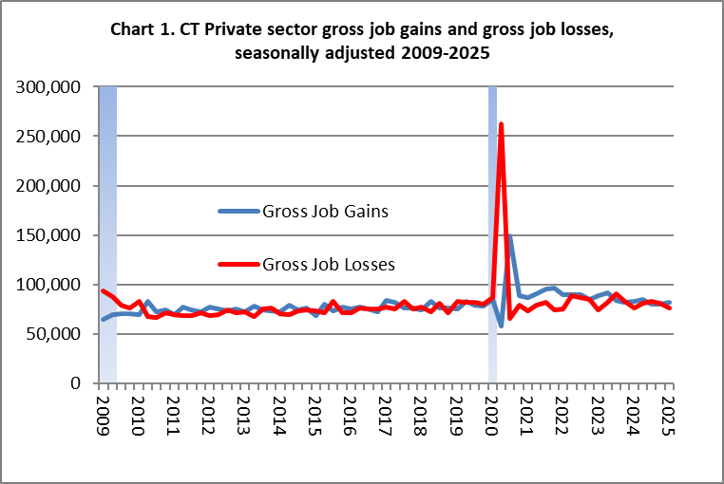

The change in the number of jobs over time is the net result of increases and decreases in employment that occur at all businesses in the economy. Business Employment Dynamics (BED) statistics track these changes in employment at private business units from the third month of one quarter to the third month of the next. Gross job gains are the sum of increases in employment from expansions at existing units and the addition of new jobs at opening units. Gross job losses are the result of contractions in employment at existing units and the loss of jobs at closing units. The difference between the number of gross job gains and the number of gross job losses is the net change in employment.
The BED data series includes gross job gains and gross job losses at the establishment level by industry subsector and for the 50 states, the District of Columbia, Puerto Rico, and the Virgin Islands, as well as annual gross job gains and annual gross job losses at the firm level by employer size class.
Gross job gains at expanding establishments totaled 63,293 in the first quarter of 2025, this gain was 1,809 jobs lower than the previous quarter.

Opening establishments accounted for 18,707 jobs gained in the first quarter of 2025, this gain was 3,701 jobs higher than the previous quarter.

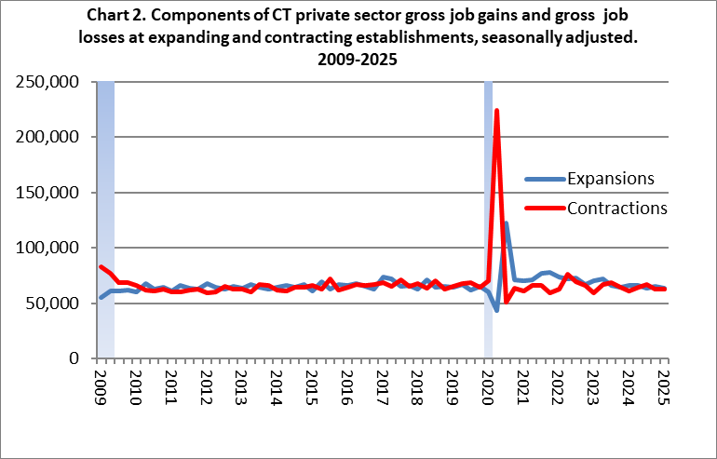

Contracting establishments lost 62,611 jobs in the first quarter of 2025, this job loss was 274 jobs lower than the prior quarter.

In the first quarter of 2025, closing establishments lost 18,032 jobs, an increase of 1,789 jobs from the previous quarter. Chart 3 shows the relationship between opening and closing-derived job change. Beginning in 2019, opening and closing-derived job change was above 2011-18 levels. During 2020Q2, the impact of the recession is illustrated by the large uptick in closing job losses and the large uptick in openings the following quarter. From 2020Q3 onward, openings have exceeded closings for 14 of 19 quarters.

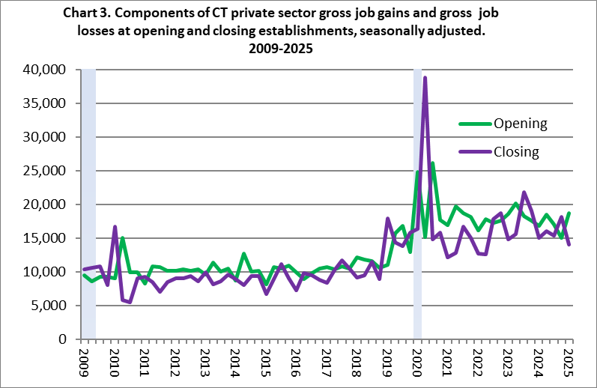

In the first quarter of 2025, there were 4,501 establishment births (a subset of the openings data). These new establishments accounted for 11,001 jobs, 1,719 more jobs than the previous quarter.

Data for establishment deaths (a subset of the closings data) are available through the second quarter of 2024, where 9,292 jobs were lost at 3,803 establishment deaths. In the prior quarter, 8,627 jobs were lost at 3,544 establishment deaths.
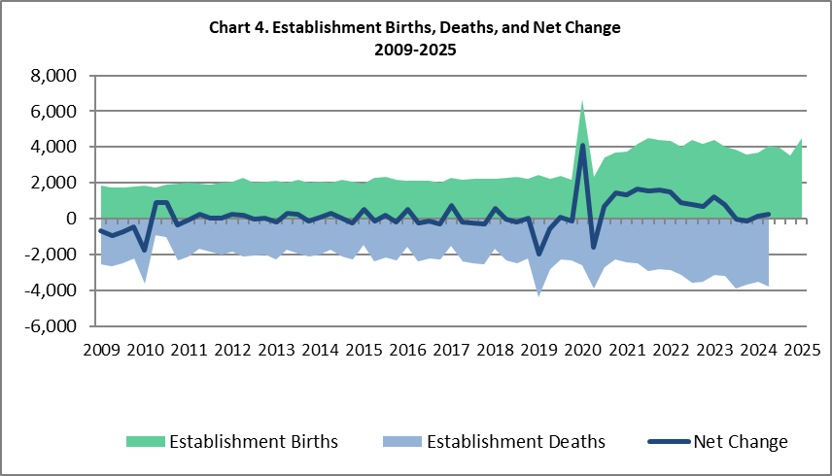
The net change of establishment births and deaths went consistently negative during the Great Recession in Connecticut from the first quarter of 2008 through the first quarter of 2010. During those 9 quarters of net decline, Connecticut averaged a net decrease of 640 establishments per quarter, with the largest net establishment decline occurring at the end of the recession, down 1,784 in the first quarter of 2010. From 2010Q2-2018Q4, it ranged between
-354 and +903 quarter-to-quarter change.
During the first half of 2019, net change fell by 1,956 establishments in the first quarter and 564 in the second. It recovered to a 76 establishment increase in the third quarter and fell by 142 in the fourth quarter of 2019. During the first quarter of 2020, net establishment births and deaths was up 4,089 and fell 1,599 during the second quarter of 2020. After the 2020 recession, net establishment change averaged a gain of 842 per quarter from the third quarter of 2020 through the second quarter of 2024. During the second quarter of 2024 (the most recent quarter available), the establishment net gain was 248 jobs.

During the first quarter of 2025, gross job gains exceeded gross job losses in 6 of 10 industries. The largest net increases occurred in Education & Health Services (+3,436) and Retail Trade (+2,426). The largest net decreasing industries were Transportation & Warehousing (-1,104 jobs) and Financial Activities (-839 jobs).

Additional Information on Business Employment Dynamics, including data for the United States, 50 states, and US territories can be found at: http://www.bls.gov/bdm/.

A Note About the Data:
The Business Employment Dynamics (BED) data are generated from Connecticut’s unemployment insurance (UI) records, enhanced through procedures conducted in association with the Bureau of Labor Statistics, and cover approximately 93% of all wage and salary workers in the state. The BED program links these records across quarters, providing a longitudinal history of employment for each establishment. These longitudinal records allow the identification of employment changes at expanding, opening, contracting, or closing establishments. Aggregating these changes, the BED data identify the gross job gains and losses, also known as job flows, in the state. These flows provide an understanding of the labor market dynamics that unfold over time. The job flows data scratches below the surface to expose the undercurrents that result in the net employment outcomes reported in other statistical series

The net change in employment from the Business Employment Dynamics data series will not match the net change in nonfarm employment produced from the monthly survey and reported in the Labor Situation. The monthly estimates are based on surveys from a sample of establishments, while the BED data are based on a quarterly census of administrative records. In addition, the monthly series has a different coverage, excluding the agriculture sector but including government, private households, and establishments not covered by the unemployment insurance program. Thus, the net over-the-quarter changes derived from the BED data may be different from the net employment change estimated from the monthly nonfarm employment series. The intended use of the BED statistics is to show the dynamic labor market flows that underlie the net changes in aggregate employment levels; data users who want to track net changes in aggregate employment levels over time should refer to monthly nonfarm data.

With the release of first quarter data each year, seasonally adjusted data for prior periods are revised and will therefore be different than figures shown in earlier releases. Please see http://www.bls.gov/bdm/ for more
detailed information.

This publication was prepared by Matthew Krzyzek, Economist at the Connecticut Department of Labor, Office of Research. If you have any questions regarding this publication, please call (860) 263-6287 or Matthew.Krzyzek@ct.gov.

